File Transfer Protocol
FTP is another commonly used application layer protocol. FTP was developed to allow for data transfers between a client and a server. An FTP client is an application that runs on a computer that is used to push and pull data from a server running an FTP daemon (FTPd).
As the figure illustrates, to successfully transfer data, FTP requires two connections between the client and the server, one for commands and replies, the other for the actual file transfer:
- The client establishes the first connection to the server for control traffic using TCP port 21, consisting of client commands and server replies.
- The client establishes the second connection to the server for the actual data transfer using TCP port 20. This connection is created every time there is data to be transferred.
The data transfer can happen in either direction. The client can download (pull) data from the server, or the client can upload (push) data to the server.
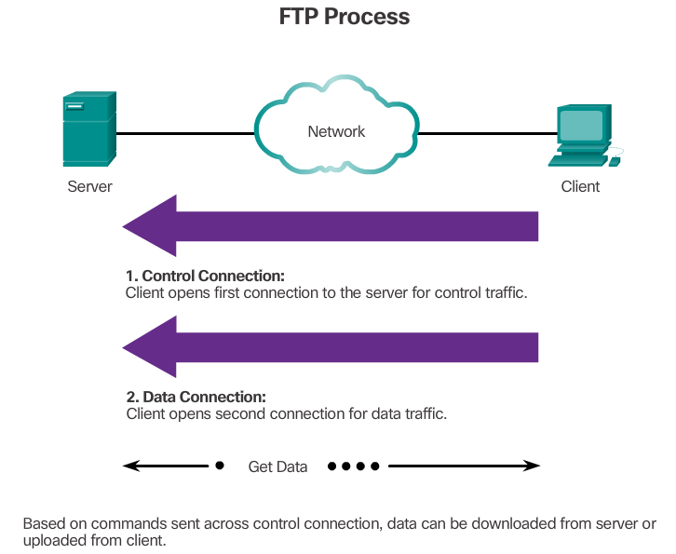
SMTP server port = 25
POP server port = 110 IMAP server port = 143

Exercises:
1. Answer the questions:
- What is FTP?
- Why was FTP developed?
- Why does FTP require two connections between the client and the server?
2. Listening:
Listen to the recording. Decide if the sentences are true (T) or false (F)
- Internet protocols are used to govern how data are exchanged between hardware devices. T/F
- Protocols cannot specify how the computers interact. T/F
- Protocols dictate how data are changed T/F
- FTP is used to develop a website T/F
- FTP is unable to upload a website from one computer to the other T/F
- An FTP client is used to log into a server T/F
- FTP clients cannot upload multiple files at once T/F

